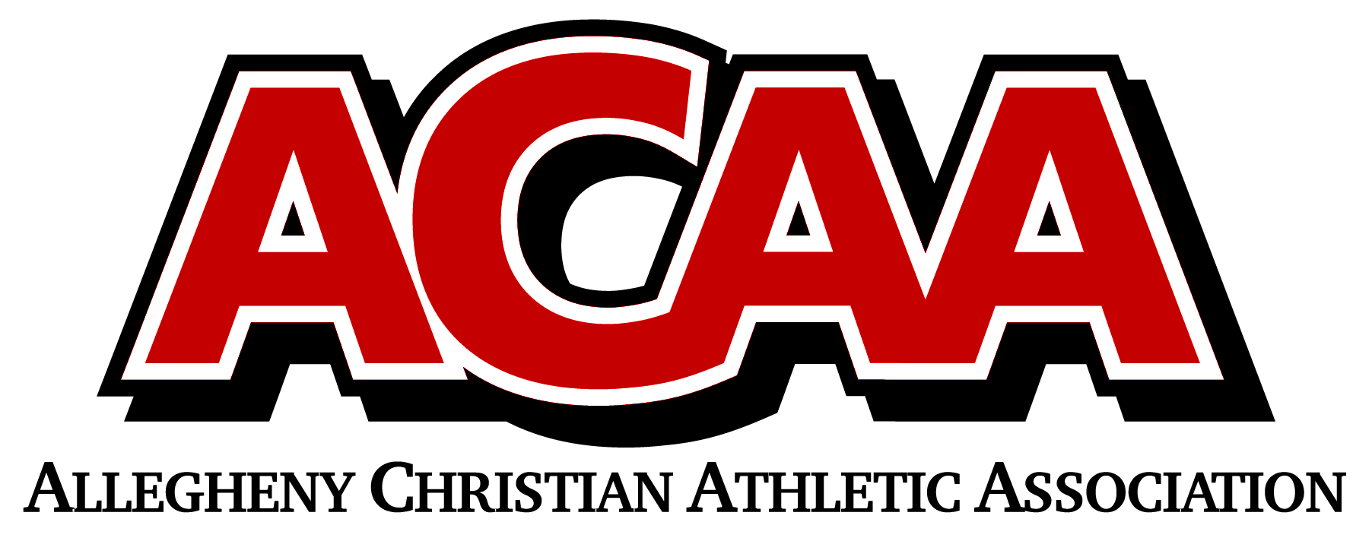

DIVISION ALIGNMENT 2022-2023

SOCCER
EASTERN DIVISION
# 1E | Juniata Christian School
# 2E | Columbia County Christian School
# 3E | Meadowbrook Christian School
# 4E | Belleville Mennonite School
# 5E | Northumberland Christian School
# 6E | BYE
# 7E | Walnut Street Christian School
# 8E | Grace Prep High School

WESTERN DIVISION
# 1W | Calvary Christian Academy
# 2W | Blair County Christian School
# 3W | Centre County Christian Academy
# 4W | Johnstown Christian School
# 5W | DuBois Christian Schools
# 6W | Great Commission Schools
# 7W | Huntington Christian Academy
# 8W | Cambria County Christian School

